**NAME: SUNIL KUMAR**

**MAIL ID:sunilkumar.jayamoorthy@gmail.com**

**Q. Difference between parametric and non-parametric tests**

**PARAMETRIC TEST:**

A parametric test is a test designed to provide the data that will then be analyzed through a branch of science called parametric statistics. Parametric statistics assumes some information about the population is already known, namely the probability distribution. As an example, the distribution of body height on the entire world is described by a normal distribution model. Similar to that, any known distribution model can be applied to a set of data. However, assuming that a certain distribution model fits a dataset means that you inherently assume some additional information is known about the population, as I’ve mentioned. The probability distribution contains different parameters that describe the exact shape of the distribution. These parameters are what parametric tests provide – each question is tailored to give an exact value of a certain parameter for each interviewed individual. Combined, the mean value of that parameter is used for the probability distribution. That means that the parametric tests also assume something about the population. If the assumptions are correct, parametric statistics applied to data provided by a parametric test will give results that are much more accurate and precise than that of a nonparametric test and statistics.

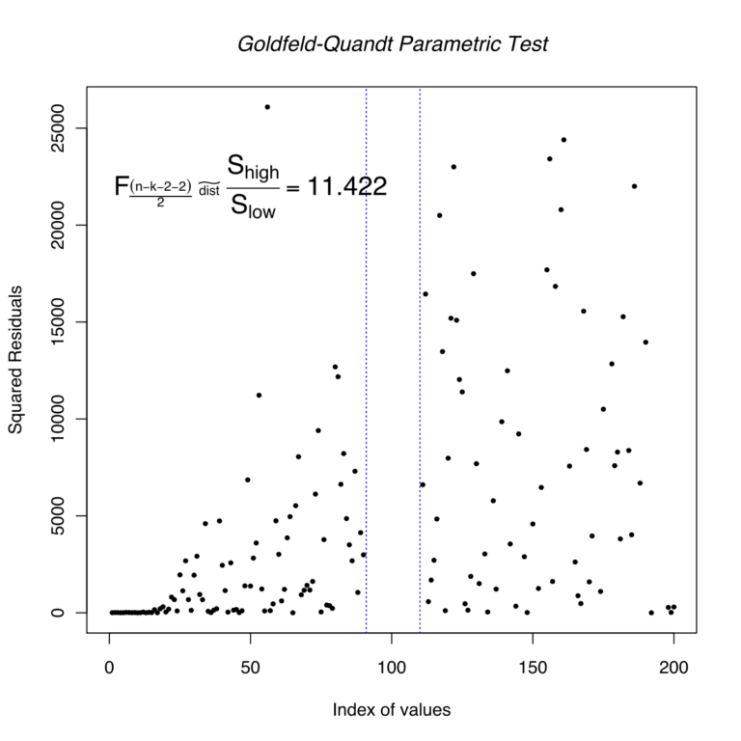

**NONPARAMETRIC TEST:**

In a similar way to parametric test and statistics, a nonparametric test and statistics exist. They’re used when the obtained data is not expected to fit a normal distribution curve, or ordinal data. A great example of ordinal data is the review you leave when you rate a certain product or [service](http://www.differencebetween.net/business/difference-between-sales-and-service/) on a scale from 1 to 5. Ordinal data in general is obtained from tests that use different rankings or orders. Therefore, it doesn’t rely on numbers or exact values for the parameters that parametric tests relied on. In fact, it doesn’t utilize parameters in any way, because it doesn’t assume a certain distribution. Usually, a parametric analysis is preferred to a nonparametric one, but if the parametric test cannot be performed due to unknown population, a resort to nonparametric tests is necessary.

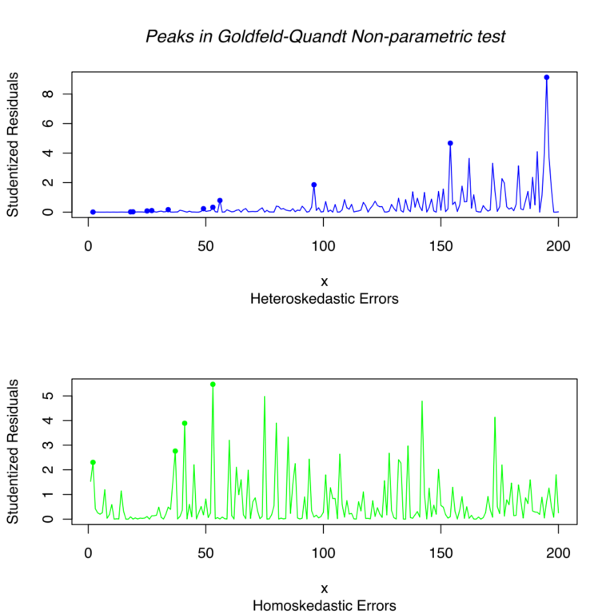

**DIFFERENCE BETWEEN PARAMETRIC AND NONPARAMETRIC TESTS**

**1) Making assumptions**

As I’ve mentioned, the parametric test makes assumptions about the population. It needs the parameters that are connected to the normal distribution that is used in the analysis, and the only way to know these parameters is to have some [knowledge](http://www.differencebetween.net/language/difference-between-intelligence-and-knowledge/) about the population. On the other hand, a nonparametric test, as the name indicates, doesn’t rely on any parameters and therefore doesn’t assume anything about the population.

**2) Probability of Parametric and Nonparametric**

The basis for the statistic analysis that will be performed on the data, in the case of parametric tests, is probabilistic distribution. On the other hand, the basis for nonparametric tests doesn’t exist – it’s completely arbitrary. This results in more flexibility and makes it easier to fit the hypothesis with the collected data.

**3) Measure of central tendency**

The measure of central tendency is a central value in a probability distribution. And although the probability distribution in the case of nonparametric statistics is arbitrary, it still exists, and therefore so does the measure of central tendency. However, those measures are different. In the case of parametric tests, it is taken to be the mean value, whereas, in the case of nonparametric tests, it is taken to be the median value.

**4) Knowledge of population parameters**

As I’ve mentioned in the first difference, information about the population varies between parametric and nonparametric tests and statistics. Namely, certain knowledge about the population is absolutely necessary for a parametric analysis, because it requires population-related parameters in order to give precise results. On the other hand, a nonparametric approach can be taken without any previous knowledge of the population.

**Parametric vs. Nonparametric Tests: Comparison chart**

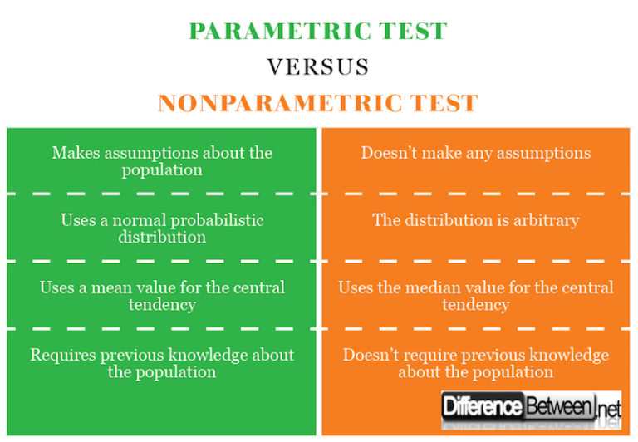

**SUMMARY OF PARAMETRIC AND NONPARAMETRIC**

* A parametric test is a test that assumes certain parameters and distributions are known about a population, contrary to the nonparametric one
* The parametric test uses a mean value, while the nonparametric one uses a median value
* The parametric approach requires previous knowledge about the population, contrary to the nonparametric approach